**🔷 Executive Summary**

Your current website for Forefront Roofing presents valuable information, but it’s missing modern visual appeal, conversion-optimized layouts, and user-friendly navigation that could significantly boost your leads and trust.

**Here's how I can help you:**

* Give your site a **modern, clean design** that builds trust.
* Make it easier for visitors to **request a quote** or **contact you**.
* Improve speed, mobile responsiveness, and SEO.
* Turn your site into a true **sales engine**.

**🔷 Section-by-Section Breakdown & Redesign Plan**

**1. Header + Navigation**

**Current Problems:**

* Overcrowded layout with repeated links.
* CTA button ("Contact Us") lacks prominence.

**What I’ll Do:**

* Streamline the top bar into a compact layout.
* Make “Get a Free Estimate” a bright sticky button visible on all pages.
* Mobile-friendly navigation with dropdowns.

**SCREENSHOT BELOW**

**Your Website:**

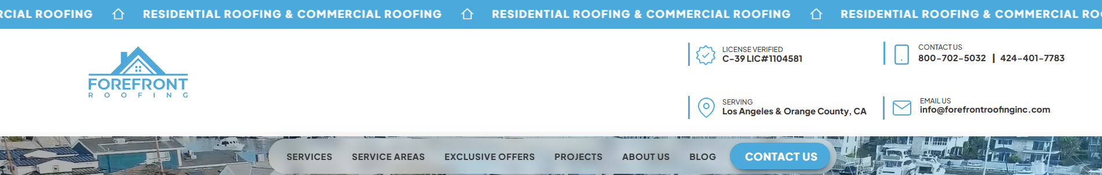

**Sample:**

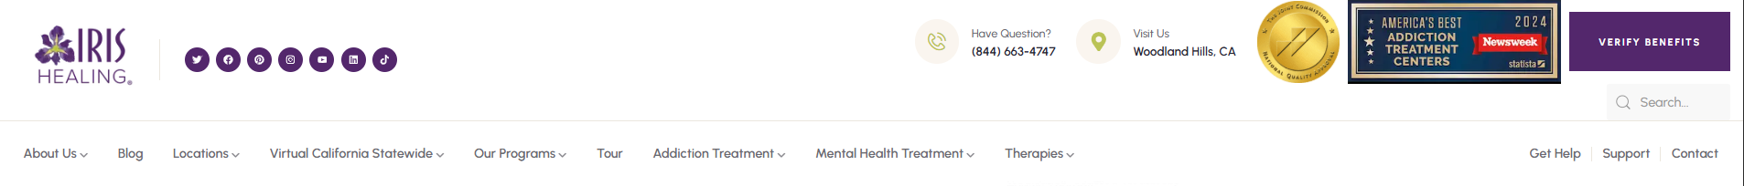

If you'd like, I can do a full site audit for you and recommend the best improvements I can implement in WordPress.